 | IQVIATM Work Instruction Analysis Sets
Document Number and Revision:
CS_WI_BS011 Revision 12
Document Owner: Carrie Eason | Author(s): Kerry Preston

PURPOSE

  - To describe the definition, implementation, review, documentation, and authorization of analysis sets (sometimes referred to as analysis populations etc.).

SCOPE

  - This work instruction (WI) applies to all projects, blinded and open-label, where IQVIA Biostatistics produces statistical outputs and/or performs statistical analyses.

ROLES AND RESPONSIBILITIES
The following roles perform tasks described within this WI:

Role | Sections
Statistical Team Leader (STL) | 6.1, 6.2, 6.3, 6.5, 6.6, 6.7
Programming Team Leader (PTL) | 6.3
Quality Control (QC) Reviewer | 6.4
Senior Biostatistical (SB) Reviewer | 6.4

DEFINITIONS
Analysis set: A set of subjects whose data are to be included in the analyses of a clinical trial and defined in the statistical section of the protocol. A typical protocol will have multiple potential analysis sets e.g., a set based upon intention-to-treat principle.
Data Review Meeting: A meeting held prior to database (DB) lock/unblinding in which the list of subjects to be included/excluded in each analysis set are reviewed and agreed.
Protocol Deviation (PD): A deviation from a Protocol occurs when Investigator site staff or a study subject does not adhere to the Protocol’s stipulated requirements, whether inadvertently or planned.

MATERIAL AND EQUIPMENT
Not Applicable

Page 1 of 12
Copyright © 1999, 2000, 2003, 2006, 2008, 2010, 2012, 2016, 2017, 2019, 2022 IQVIA. All rights reserved. The contents of this document are confidential and proprietary to IQVIA Holdings Inc. and its subsidiaries. Unauthorized use, disclosure or reproduction is strictly prohibited.

PROCEDURE
Protocol deviation information is used in the finalization of the analysis set assignments and evaluation of reason(s) for exclusion of subjects from one or more of the analysis sets. The finalization of analysis sets should occur before database lock and routine study unblinding. Note that some protocol deviation information is not available until after database lock and unblinding. From a statistical analysis perspective, the reason(s) for exclusion of subjects may be protocol deviations or other factors affecting the efficacy outcome or treatment of the subject.

This WI is focused on the Analysis Set definitions and subsequent assignments. For more information on the protocol deviation process refer to CS_WI_PL0038: Handling of Protocol Deviations and CS_WI_BS005: Statistical Analysis Plans (Covering Table Shells).

The workflow diagram for this work instruction is in Appendix A: Analysis Set Assignment Workflow.

  - Planning of Analysis Set Assignment Process

No: | Who: | Step: | When:
6.1.1 | STL | Confirms with the customer, clinical/project leadership and Data Management (as appropriate) the process for receiving protocol deviation data recorded during the clinical conduct of the study.  For studies that are managed according to the IQVIA Project Leadership procedures, follow CS_WI_PL0038: Handling of Protocol Deviations. | Preparing the Statistical Analysis Plan (SAP)
6.1.2 | STL | Determines with the customer, clinical/project leadership and Data Management (as appropriate) the process for analysis set assignment, including:  - Agreed terminology.  - The use of customer or IQVIA standards and requirements.  - Process to be followed if gaps are identified, versus IQVIA best practice guidance.  - Number, timing and format of data review meetings, or equivalent process, and the state of the data for each data review (e.g., data as available or final “clean” state).  - IQVIA Biostatistics responsibilities (including the deliverables to be provided prior to the data review(s)).  - IQVIA Biostatistics contracted Scope of Work. | Preparing the SAP

No: | Who: | Step: | When:
 |  | Note: It is recommended the Lead Medical Writer (MW) be informed about the discussions with respect to the analysis set assignment process.

  - Definition of Analysis Sets

No: | Who: | Step: | When:
6.2.1 | STL | Considers the following to ensure that the analysis set definitions detailed in the SAP, or relevant documentation, are accurate, consistent, clear, complete and appropriate in view of the trial design and objectives:  - The International Council for Harmonization (ICH) Guideline (Topic E9) on Statistical Principles for Clinical Trials specifications for defining the analysis sets.  - The analysis set definitions specified in the Clinical Study Protocol (see Statistical Review and Input to a Clinical Trial Protocol, CS_WI_BS006).  - The PD INITIATIVE BEST PRACTICE GUIDANCE ROLL-  OUT best practice guidance located in the Biostatistics Training folder in ELVIS.  - The (Blind) Data Review ((B)DR) Plan template, located in the Biostatistics Training folder in ELVIS, for guidance in the definition of analysis sets. The template may be used to document the planning of the analysis sets. | Preparing the SAP
6.2.2 | STL | - Includes in the SAP, or relevant documentation, the analysis set definitions, including potential reason(s) for exclusion from one or more analysis sets (see Statistical Analysis Plans (Covering Table Shells) CS_WI_BS005)). The reason(s) for exclusion from analysis sets can be protocol deviations or other factors affecting the efficacy outcome or treatment of the subject.  - Requests a formal protocol amendment if there is a major change to the protocol definition of the analysis set on which the primary efficacy analysis is based. | Preparing the SAP
6.2.3 | STL | - Updates the SAP, or relevant documentation, for changes to rules defining the analysis sets or identifying reason(s) for exclusion during the conduct of the study prior to database lock and routine study unblinding. | Following the data review meeting (or equivalent finalization process) and prior to database lock and routine study unblinding

6.2.4 | STL | - Documents any changes to the analysis set definitions, including potential reason(s) for exclusion from one or more analysis sets, made after routine study unblinding on a Changes to Planned Statistical Analyses Form (CS_FM_BS006), or equivalent documentation (e.g., Minutes for a data review meeting, or final authorized (Blind) Data Review (B)DR report).  - Provides the authorized Changes to Planned Statistical Analyses Form, or equivalent documentation, to the Lead MW. | After routine study unblinding

  - Implementation of Analysis Set Definitions

No: | Who: | Step: | When:
6.3.1 | STL | Assigns subjects to analysis sets in accordance with the definitions documented in the authorized SAP, or relevant documentation, and the process determined in Section 6.1.  Considers the following when implementing the analysis set definitions:  - The PD INITIATIVE BEST PRACTICE GUIDANCE ROLL-  OUT best practice guidance located in the Biostatistics Training folder in ELVIS.  - Analysis set definitions may be definitively determined algorithmically from the study database according to the rules.  - Analysis set definitions may require supplemental data that does not form part of the clinical database (e.g., a list of disallowed concomitant medication codes identified by the medical advisor) to make assignment decisions; such information must be documented and authorized by the customer prior to routine study unblinding. | After finalization of the SAP but prior to routine study unblinding
6.3.2 | STL/ PTL  (or designee) | If analysis set assignment requires review of by-subject data listings, the listings must be prepared in accordance with Statistical Output (CS_WI_BS014).  Considers the following when preparing by-subject data listings:  - By-subject data listings prepared in support of analysis set assignments should be programmed from the RAW datasets, although if available, a selection of the derived datasets can be used. The use of derived datasets verifies that imputation-based considerations are not missed. | Preparing by- subject data listings

- Creates SAS datasets containing the relevant information per specific listing/output.
- Care should be taken with data (efficacy, safety, pharmacokinetic data, etc.) that may potentially unblind the reviewer.
6.3.3 | STL | Considers the following alternative sources when assigning subjects to analysis sets:  - When available, reviews the protocol deviations log, or equivalent document as a source of potential reason(s) for analysis set exclusion per the analysis set definitions.  - For blinded and randomized studies, identifies randomization deviations and/or subject unblinding prior to routine study unblinding using the Protocol Deviation Log (or equivalent document), data transfers, and any other available information.  - Considers information from the Data Handling Report (CS_WI_DM0413) and any issues identified during Statistical Review of and Authorization to Lock a Database (CS_WI_BS010). | Assigning subjects to analysis sets
6.3.4 | STL | Documents details about subjects’ proposed assignment to the analysis sets in an EXCEL file.  For short-term studies (e.g., the time between first patient in (FPI) and last patient out (LPO) is less than 12 months), it is recommended that the documentation be compiled on data as near to final as possible to reduce follow-up actions after a data review meeting (or equivalent process).  For longer term studies (time from FPI to LPO is > 12 months), documentation should be collated on a regular basis, for example, document decisions relating to protocol deviations after each PD review or data review meeting. This will avoid there being a large backlog when finalizing analysis set assignment decisions in the lead up to DB lock.  Note: This only applies to analysis sets that can be determined prior to routine study unblinding. A Pharmacokinetic analysis set, for example, might only be defined following routine study unblinding and as such, the STL must verify that procedures are  detailed in the relevant documentation to finalize this analysis set in an unbiased manner following routine study unblinding. | Prior to a data review meeting (or equivalent finalization process)
6.3.5 | STL | After the QC of outputs supporting analysis set assignments (see Section 6.4), sends analysis set assignment and reason(s) for exclusion documentation to the customer, and other relevant parties, to allow for review and comment. | Prior to a data review meeting (or equivalent finalization process)

6.3.6 | STL | If analysis set assignment and reason(s) for exclusion are finalized as part of a data review meeting, or equivalent finalization process:  - Facilitates the data review meeting, or equivalent per the process agreed in Section 6.1.  - Documents analysis set assignment and reason(s) for exclusion of subjects in minutes for the final data review meeting, or as part of an equivalent report.  - Documents decisions regarding data issues as identified in the data handling report and data issues log potentially impacting the planned analyses in minutes for the final data review meeting, or as part of an equivalent report.  - Documents subject-level decisions (e.g., not to exclude a subject when an exclusion rule indicates the subject meets an exclusion criterion), with accompanying explanations, in minutes of the final data review meeting, or as part of an equivalent report.  - Records/reviews minutes to the meeting which can take the form of an EXCEL spreadsheet (recommended), a report, and/or actual meeting minutes as agreed with the customer.  - Considers the BDR Report template located in the Biostatistics Training folder in ELVIS, for guidance in the reporting of analysis set assignments, associated reasons for exclusion(s) from analysis sets and relevant data handling decisions.  - Informs the Lead MW of decisions that may impact the clinical study report (CSR). | At scheduled data review meeting (or equivalent finalization process)
6.3.7 | STL | Follows up on actions as agreed at the data review meeting (or equivalent finalization process). For example, additional data issues requiring query to the sites. | Following the data review meeting (or equivalent finalization process) and prior to database lock and routine study unblinding
6.3.8 | STL | If randomized and actual treatment assignments, or pharmacokinetic (or similar) data will affect the analysis set assignments, checks:  - Actual versus randomized treatment deviations and ensures that subjects with such deviations are excluded from the | Following database lock and routine study unblinding and prior to final analysis.

relevant analysis set and are handled in accordance with the SAP, or relevant documentation.
- Final assignment to the Pharmacokinetic or other analysis sets requiring knowledge of the randomized and actual treatment assignments.
- Documents the updated analysis set assignments and reason(s) for exclusion of subjects.
6.3.9 | STL/ PTL | Adds analysis set flags (e.g., variables that indicate the analysis sets to which a subject belongs) to a derived dataset produced in accordance with Derived Datasets (CS_WI_BS013).  - Creates flag variables in a derived dataset to indicate analysis set inclusion.  - Creates a variable indicating the reason(s) for exclusion if needed for statistical outputs.  - Includes these variables in one derived dataset. | After finalization of the analysis set assignments

  - QC of Outputs Supporting Analysis Set Assignments

No: | Who: | Step: | When:
6.4.1 | QC  Reviewer | - Completes the checks described in Approaches to QC (CS_WI_BS015) and Approaches to QC: Appendix E - QC of Deliverables for the determination of Analysis Sets (CS_OD_BS0233).  - Follows the process defined in Statistical Output (CS_WI_BS014) for any programmed outputs created in support of analysis set decisions.  - Updates the tracking document for any derived datasets or statistical output produced in support of analysis set decisions and completes a Reviewer Feedback Form (RFF) (CS_FM_BS007) to document review. Applicable Biostatistics web-based solutions/systems may be used instead of the tracking document or RFF. | Performing QC of analysis set assignments
6.4.2 | SB  Reviewer | - Completes the checks described in Approaches to QC (CS_WI_BS015) and Approaches to QC: Appendix E - QC of Deliverables for the determination of Analysis Sets (CS_OD_BS0233).  - Checks that the number of subjects excluded from each analysis set is plausible.  - Completes a RFF (CS_FM_BS007) or applicable Biostatistics web-based solution/system to document review | Reviewing analysis set assignments

  - Authorization of Analysis Set Assignments

No: | Who: | Step: | When:
6.5.1 | STL | Obtains customer authorization on:  - The final analysis set assignments, and  - reason(s) for exclusion from analysis sets,  using the Customer Authorization Form CS_FM_BS002 (CAF) or equivalent signature page of alternative documentation.  The timing (date, time and time-zone) of authorization of the analysis sets assignment in relation to database lock and routine study unblinding (see Unblinding work instruction CS_WI_BS003) must be clearly documented especially where authorization and database lock occur on the same date.  Note: Authorization of analysis set assignments, and associated reason(s) for exclusion, is also required for open label studies. When the study team is blinded to the treatment assignments on an  open-label study, the process is the same as required for a blinded study. | Prior to routine study unblinding
6.5.2 | STL | Obtains customer authorization on:  - Any additional analysis set assignments, and  related reason(s) for exclusion from analysis sets, that resulted from the review of actual versus randomized treatment deviations, pharmacokinetic or other analysis sets requiring knowledge of the randomized and actual treatment assignments, using the Customer Authorization Form CS_FM_BS002 (CAF) or equivalent signature page of alternative documentation. | Following database lock and routine study unblinding and prior to final analysis.

  - Finalization

No: | Who: | Step: | When:
6.6.1 | STL | Provides the final analysis set assignment documentation to the Lead MW for their incorporation/use in the CSR. | After authorization of analysis sets
6.6.2 | STL | Notifies the Lead MW of any changes to the analysis sets that will impact the CSR by means of an authorized Changes to Planned Statistical Analyses Form (CS_FM_BS006), or equivalent authorized documentation. | After changes to the authorized analysis sets

  - Documentation

No: | Who: | Step: | When:
6.7.1 | STL | Files the following (where applicable) in the relevant folder of the Trial Master File (TMF) or eTMF as per the Management and Filing of Biostatistics Documentation work instruction  (CS_WI_BS0237): | After finalization and authorization of analysis sets

No: | Who: | Step: | When:
- Any by-subject listings or other materials prepared in support of analysis set assignments.
- Authorization of final rules and/or decisions for subjects excluded from (or included in) each analysis set.
- Customer correspondence about the assignment of subjects to analysis sets.
- Any data review meeting minutes or equivalent documents.
- RFF(s) (CS_FM_BS007).
- Sign-off page for analysis set assignment or CAF (CS_FM_BS002).
- Changes to Planned Statistical Analyses Form (CS_FM_BS006).

- SUPPORTING DOCUMENTATION
DOCUMENT NUMBER | TITLE
ESOP References
7.1 CS_FM_BS002 | Customer Authorization Form
7.2 CS_FM_BS006 | Changes to Planned Statistical Analyses Form
7.3 CS_FM_BS007 | Reviewer Feedback Form
7.4 CS_OD_BS0233 | Approaches to QC: Appendix E - QC of Deliverables for the determination of Analysis Sets.
7.5 CS_WI_BS003 | Unblinding
7.6 CS_WI_BS005 | Statistical Analysis Plans (Covering Table Shells)
7.7 CS_WI_BS006 | Statistical Review and Input to a Clinical Trial Protocol
7.8 CS_WI_BS010 | Statistical Review of and Authorization to Lock a Database
7.9 CS_WI_BS013 | Derived Datasets
7.10 CS_WI_BS014 | Statistical Output
7.11 CS_WI_BS015 | Approaches to QC
7.12 CS_WI_BS0237 | Management and Filing of Biostatistics Documentation
7.13 CS_WI_DM0413 | Data Handling Report
7.14 CS_WI_PL0038 | Handling of Protocol Deviations
External References
7.15 ICH-GCP: E9 | Statistical Principles for Clinical Trials
7.16 Best Practice  Guidance | PD INITIATIVE BEST PRACTICE GUIDANCE ROLL-OUT

DOCUMENT NUMBER | TITLE
7.17 Best Practice Plan Template | (B)DR Plan template
7.18 Best Practice Report Template | (B)DR Report template

- SUPERSEDES
DOCUMENT NUMBER | TITLE | REVISION NUMBER
8.1 CS_WI_BS011 | Analysis Sets | 11

- MODIFICATION FROM PREVIOUS REVISION
CHANGE | SECTION REFERENCE | JUSTIFICATION
Updated minor grammatical and formatting errors. | All | Improve clarity and consistency
Changed LP to PTL | Throughout | Consistency with other SOP documents
Add that applicable Biostatistics web-based solutions/systems can be used instead of a tracking document or RFF to document reviews | Throughout | New process
Added definition of data review meeting. | Section 4.0 | For clarity
Added hyperlinks to best practice guidance documentation and BDR Plan and report templates | Sections 6.0, 6.2.1, 6.3.6, 7.0 | For ease
Changed the name of the best practice guidance | Section 6.2.1, 6.3.1 | Correction
Removed “SAS” from the description of the derived datasets | Section 6.3.2 | R derived datasets could be used
Added details that PDs should be reviewed, and subject analysis set assignments documented, on a regular basis for long-term studies. | Section 6.3.4 | Process improvement
Added reference to

CHANGE | SECTION REFERENCE | JUSTIFICATION
Changed references to updated records management documents | Section 6.7 | To reflect current controlled documents

- APPENDICES

  - Appendix A: Analysis Set Assignment Workflow Prior to DB Lock
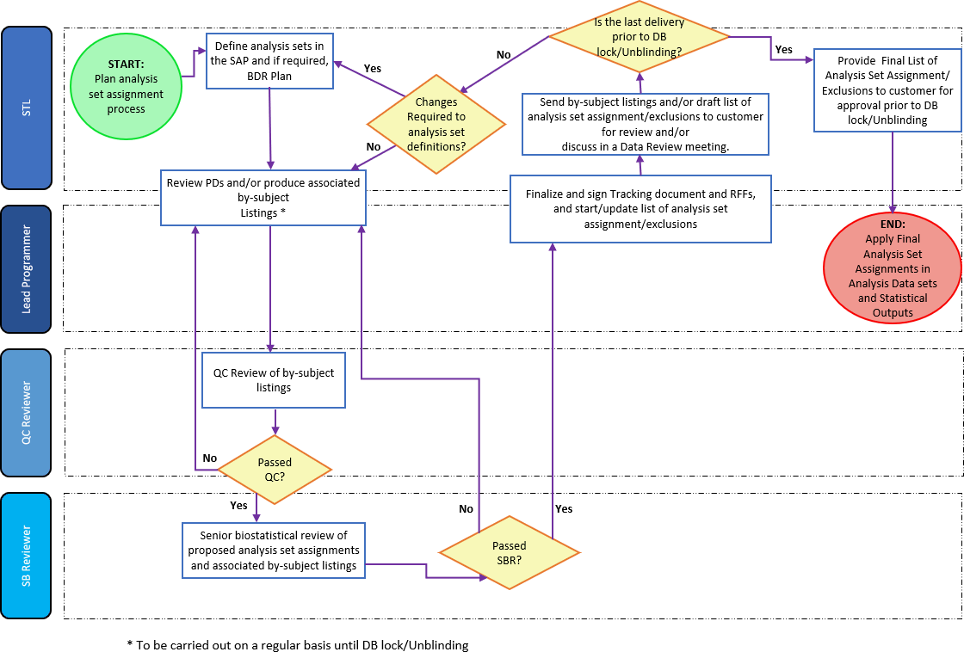

Page 12 of 12
Copyright © 1999, 2000, 2003, 2006, 2008, 2010, 2012, 2016, 2017, 2019, 2022 IQVIA. All rights reserved. The contents of this document are confidential and proprietary to IQVIA Holdings Inc. and its subsidiaries. Unauthorized use, disclosure or reproduction is strictly prohibited.

Standard Operating Procedure Approval Signature(s)
This is a representation of an electronic record that was signed electronically in Content Server.
This page is the manifestation of the electronic signature(s) used in compliance with the organization’s electronic signature policies and procedures
Refer to Signatories CV for Business Title.

UserName: Willmott, Corinne (q778849) Title:
Date: Tuesday, 15 November 2022, 09:45 AM Eastern Daylight Time Meaning: Signing this Document Indicates My Approval
================================================

UserName: Bickford, Emma (q637065) Title:
Date: Tuesday, 15 November 2022, 01:47 PM Eastern Daylight Time Meaning: Signing this Document Indicates My Approval
================================================

